Lessons from the Past: The Deck
Dave Price
One of the most famous decks in Magic history, this deck so dominated Vintage or Type 1 for a span of time that it became known as simply "The Deck." The Deck is traditionally attributed to Brian Weissman on the west coast, but a similar blue/white based control deck was developed at the same time in the midwest and on the east coast by Matt Place and Chris Pikula.

A great deal can be gained from evaluating the fundamental concepts of old decks and seeing if they can make the transition into a new environment...
So what relevance does this deck have on deckbuilding today? We've seen Necropotence decks repeatedly dominate tournaments, Tolarian Academy combo decks come and go, and have died at the hands of Donated Illusions of Grandeur. It seems silly that a deck designed five or more years ago in a format like Type 1 could be useful to us now, when even the Constructed decks that won the previous week's PTQ are often outdated by the time the next weekend rolls around. Still, many decks that seem irrelevant or outdated helped us learn key concepts that we now take for granted or may have even forgotten. I find it useful sometimes to take a look at old decks, how they worked, and see what, if anything, can be applied to a new environment.
The Deck 1996
Main Deck |  | Sideboard
4 Tundra  2 Volcanic Island  4 City of Brass  3 Strip Mine  4 Islands  3 Plains  5 Moxes  1 Sol Ring  1 Black Lotus  1 Library of Alexandria  1 Jayemdae Tome  1 Ancestral Recall  1 Braingeyser  4 Disenchant | 4 Swords to Plowshares  4 Mana Drain  2 Counterspell  2 Red Elemental Blast  2 Disrupting Scepter  2 Moat  2 Serra Angel  1 Mirror Universe  1 Amnesia (formerly Mind Twist)  1 Timetwister  1 Regrowth  1 Demonic Tutor  1 Timewalk  1 Recall

Key Concepts
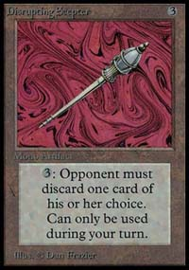
The most famous concept attributed to The Deck is the idea of card advantage. The deck had a number of ways to generate card advantage, from something as simple as Ancestral Recall, which provides three cards in exchange for the one, to nullifying a number of creatures with a single Moat or forcing the opponent to discard a number of cards with a Disrupting Scepter. The idea of card advantage is to use one of your cards to produce even more cards for yourself or to deprive the opponent of multiple cards. Using a Moat or Wrath of God to effectively eliminate a number of the opponent's ground creatures is an example of card advantage. Just as some cards tend to help you nullify multiple cards of the opponent or produce extra cards for you, other types of spells tend to cost you cards. For instance, if you cast a creature enchantment like an Unholy Strength on one of your creatures and the opponent removes that creature from the game with a Swords to Plowshares, you have lost two cards for the opponent's one. Similarly, spells like Arcane Denial and Howling Mine that allow the opponent to draw cards as well as you, often give the opponent an advantage. By utilizing cards that provide you with card advantage and avoiding spells like creature enchantments that tend to cost you, you can end up with more cards and resources than the opponent, which clearly tips the scales in your favor.
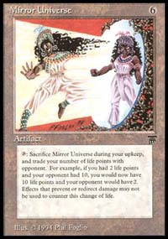
A long time ago, this card could win games by itself
Still, not all cards can produce card advantage. Some spells offer only one for one trades and these types of cards are also essential to a control deck. Another of The Deck's key concepts is that spells should be as efficient and as flexible as possible. A good example of this is Counterspell. While one can only stop a single spell with a Counterspell, Counterspell is both efficient, costing only two blue mana, and flexible, as it can counter almost anything, aside from a land or a spell with special text like Obliterate or Kavu Chameleon. The deck used a number of flexible spells, Counterspells and Mana Drains for countermagic, Disenchant to deal with both artifacts and enchantments, and even Serra Angel. The Deck's offensive threat, Serra Angel, also serves as a great defensive card. Since Serra Angel doesn't tap to attack, it can block the opponent's attackers even as it is killing the opponent. The typical flaw of control decks is that they need to find the right answers to the opponent's threats or they risk losing the game. If you fill your deck with generic and flexible answers like Counterspell, you stand a far greater chance of having the right answer at the right time.
The primary goal of The Deck is survival. It attempts to not lose, nullifying the opponent's threats and developing its resources at the same time. If it can survive for a period of time, gaining card advantage along the way (or at the very least, not losing cards), then it can eventually take control of the game and win with one of its few victory conditions, the Serra Angel or Mirror Universe.

So What Now?
Despite the various formats that have developed since The Deck's inception, its concepts and methods have been imitated and used again and again, from as far back as the very first Pro Tour - New York, which Michael Loconto won with a Blue/White Millstone deck. This deck bore a striking resemblance to The Deck and it was made for the Standard environment. It used countermagic, mass removal like Wrath of God and Balance, and Millstone for the win.
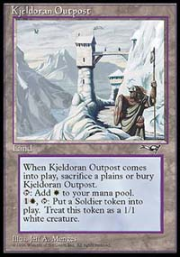
Similarly, in Ice Age/Alliances Block Constructed, Jon Finkel played a Counterpost deck to the top 8 of the Junior portion of Pro Tour - Columbus. This deck used Pyroclasm for mass removal, Swords to Plowshares, Disenchants, and Counterspells as flexible answers, Thawing Glaciers to produce card advantage and Kjeldoran Outpost for the win. More so than Loconto's Millstone deck, Finkel's Counterpost deck adhered to the many principles introduced by The Deck, whether intentionally or not. Even its kill card, Kjeldoran Outpost, was also a potent defensive card, able to produce blockers for the opponent's creatures. Later on, the Counterpost deck made the transition from Block Constructed to the Standard environment and even appeared in Extended.
One can even argue that many of the mono-blue Draw Go decks were based on the same concepts as The Deck, only using artifacts like Powder Keg and Nevinyrral's Disk instead of the white spells like Disenchant, Swords to Plowshares, and Moat. If the concepts pioneered by The Deck have appeared in Block Constructed, Standard, Extended and Vintage, it is no surprise that they might be valuable when examining the new Standard.
Surprisingly, a number of key cards in The Deck can still be found in the Standard environment. Disrupting Scepter and Jayemdae Tome are still in print, as well as Counterspell and Disenchant. In addition, a number of new spells have been introduced that provide possible replacements for old components of The Deck. Lets take a look at a few:
Blinding Angel
Like Serra Angel, this creature is not only an offensive threat that is difficult to stop, but a potent defensive creature. It is a 2/4 flier, making it difficult to kill with direct damage and difficult to block. In addition, each time it damages the opponent, it prevents the opponent's creatures from attacking.
Mageta the Lion
Another good Serra Angel/Mirror Universe replacement, Mageta the Lion serves as both a threat and a powerful defensive tool. This 3/3 ground creature can be used to create a "Wrath of God" type effect, destroying every creature in play but itself.
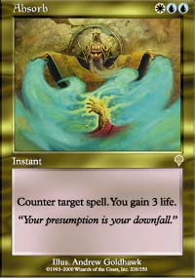
Absorb
An efficient and flexible counterspell for blue/white, it not only can counter a spell for two blue and a white, but it provides three life as a side effect which can go a long way in keeping the control player alive. While its certainly no Mana Drain, it is both efficient and flexible and fits the criteria for The Deck.
Prohibit
Another efficient counterspell, it can counter a cheap spells for only a blue and a colorless and can counter slightly more expensive spells for an additional two generic mana. Since there is no real replacement for the restricted cards found in The Deck, one likely solution will be to replace them with extra countermagic, kill cards, and other utility spells.
Teferi's Moat
For one blue, one white, and three generic mana, Teferi's Moat can provide much the same effect as Moat in the old deck, preventing ground creatures of a given color from attacking you. In addition, unlike Moat, it still allows you to attack the opponent with your ground creatures, like Mageta the Lion.
Story Circle
This card, too, is a flexible answer to many possible threats. It can nullify the opponent's creatures much like Moat did, and it also deals with a number of typically hard-to-stop cards like Hammer of Bogardan, Nether Spirit, and Pyre Zombie.
Dismantling Blow
While Disenchant is still in print, Dismantling Blow deserves a good solid look. This card provides the same utility as Disenchant for one generic mana more and can also be used to gain card advantage in the mid to late game by paying the kicker cost.
Fact or Fiction
More expensive than Ancestral Recall, to be sure, it does provide a similar level of card advantage, guaranteeing the caster at least three cards if that's what he or she desires. This spell is shaping up to be one of the defining cards in the new Standard environment.
Adarkar Wastes and Coastal Tower
Although not quite as good as Tundra, these two blue/white dual lands get the job done fine.
Let's try and fit some of these replacements into this old version of The Deck and see what we come up with. It may not be tuned, but it can start us on the right track to finding a powerful Standard deck.
Blue/White Control
Main Deck |  | Sideboard
4 Adarkar Waste  4 Coastal Towers  10 Islands  9 Plains  4 Fact or Fiction  4 Dismantling Blow  4 Wrath of God  4 Prohibit | 4 Counterspell  4 Absorb  2 Disrupting Scepter  2 Story Circle  1 Teferi's Moat  2 Blinding Angel  2 Mageta the Lion
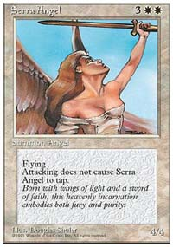
We've replaced the old threats, Serra Angel and Mirror Universe, with new ones that also serve as a strong defense, Blinding Angel and Mageta the Lion. We've replaced Swords to Plowshares with the more expensive Wrath of God, the old card drawing with Fact or Fiction, and Moat with Story Circle and Teferi's Moat. Since there are no replacements for many of the restricted cards like Regrowth, Time Walk, and Demonic Tutor, we've added a bit of redundancy, including an extra Moat-like card, an extra threat, and additional countermagic.
Deckbuilding always involves a bit of hit or miss. What can appear to be a good idea might be a flop and some seemingly silly combos can turn out to be deadly. But if you find yourself missing a lot, then one way of helping the process along is to build on what other have done in the past. A great deal can be gained from evaluating old decks and their fundamental concepts and seeing if they can make the transition into a new environment and succeed. Can this new blue/white deck hold its own in Standard? That remains to be seen, but it can rarely hurt to try. While this deck may be untuned, with a bit of playtesting, we can learn which concepts and cards still work and which need to be adjusted for the new times.
So if you are at a loss for what type of deck to design or how to build a particular deck archetype, try examining powerful and successful decks from the past and see what they show you. There are a number of great resources on the web including the Event Coverage archive here at the Sideboard that can help you in this task.

